**Supplemental Materials**

**The Number Line Is a Critical Spatial-Numerical Representation: Evidence From a Fraction Intervention**

**by N. Hamdan & E. A. Gunderson, 2016, *Developmental Psychology***

**http://dx.doi.org/10.1037/dev0000252**

Table A

*Magnitude Comparison items by trained and untrained and bigger whole number strategy category.*

|  |  |  |
| --- | --- | --- |
| **Item** | **Bigger Whole Number Strategy Category** | **Trained or Untrained** |
| 3/4 versus 1/2 | Consistent | Trained |
| 2/5 versus 4/5 | Consistent | Trained |
| 1/4 versus 4/5 | Consistent | Trained |
| 4/6 versus 5/6 | Consistent | Untrained |
| 6/7 versus 5/7 | Consistent | Untrained |
| 6/7 versus 2/6 | Consistent | Untrained |
| 1/2 versus 1/4 | Inconsistent | Trained |
| 1/2 versus 2/5 | Inconsistent | Trained |
| 1/5 versus 1/4 | Inconsistent | Trained |
| 1/5 versus 1/2 | Inconsistent | Trained |
| 3/5 versus 3/4 | Inconsistent | Trained |
| 2/5 versus 2/4 | Inconsistent | Trained |
| 2/7 versus 1/3 | Inconsistent | Untrained |
| 2/3 versus 3/6 | Inconsistent | Untrained |
| 1/3 versus 1/6 | Inconsistent | Untrained |
| 2/3 versus 3/7 | Inconsistent | Untrained |
| 2/4 versus 1/5 | Ambiguous | Trained |
| 3/7 versus 4/6 | Ambiguous | Untrained |
| 1/7 versus 2/6 | Ambiguous | Untrained |
| 1/6 versus 2/3 | Ambiguous | Untrained |

*Number Line and Area Model estimation items.*

Trained (6 items): 1/2, 1/4, 3/4, 1/5, 2/5, 4/5

Untrained (8 items): 1/3, 2/3, 1/6, 4/6, 5/6, 1/7, 3/7, 6/7

*Table B.* Correlations between fraction magnitude task performance, by condition.

|  |  |  |  |  |  |
| --- | --- | --- | --- | --- | --- |
|  | 1. | 2. | 3. | 4. | 5. |
| **Number Line condition (*n*=39)** |  |  |  |  |  |
| 1. Pretest number line estimation (PAE) | - |  |  |  |  |
| 2. Pretest area model estimation (PAE) | 0.11 | - |  |  |  |
| 3. Pretest magnitude comparison accuracy | -0.17 | 0.02 | - |  |  |
| 4. Posttest number line estimation (PAE) | 0.33* | 0.07 | -0.25 | - |  |
| 5. Posttest area model estimation (PAE) | 0.31 | 0.53*** | 0.01 | 0.12 | - |
| 6. Posttest magnitude comparison accuracy | -0.25 | -0.15 | 0.63*** | -0.24 | -0.27 |
| **Area Model condition (*n*=37)** |  |  |  |  |  |
| 1. Pretest number line estimation (PAE) | - |  |  |  |  |
| 2. Pretest area model estimation (PAE) | 0.01 | - |  |  |  |
| 3. Pretest magnitude comparison accuracy | -0.12 | 0.14 | - |  |  |
| 4. Posttest number line estimation (PAE) | 0.42* | 0.20 | -0.12 | - |  |
| 5. Posttest area model estimation (PAE) | 0.06 | 0.12 | 0.05 | 0.05 | - |
| 6. Posttest magnitude comparison accuracy | -0.33 | -0.06 | 0.74*** | -0.25 | -0.13 |
| **Crossword Puzzle condition (*n*=38)** |  |  |  |  |  |
| 1. Pretest number line estimation (PAE) | - |  |  |  |  |
| 2. Pretest area model estimation (PAE) | 0.02 | - |  |  |  |
| 3. Pretest magnitude comparison accuracy | -0.01 | 0.38* | - |  |  |
| 4. Posttest number line estimation (PAE) | 0.25 | 0.26 | 0.28 | - |  |
| 5. Posttest area model estimation (PAE) | 0.01 | 0.52*** | 0.11 | -0.06 | - |
| 6. Posttest magnitude comparison accuracy | -0.26 | 0.24 | 0.57*** | 0.22 | -0.14 |

\**p*<.05, \*\**p*<.01, \*\*\**p*<.001

**Number Line Training Script**

**Notes:** During training the experimenter replaced “x” with the current fraction’s numerator and “y” with the current fraction’s denominator. “Remediation” refers to a pre-printed, correct answer to each fraction training step. These remediation sheets were shown to all children, regardless of whether they answered correctly or not.

**Experimenter-led instruction:**

*Today we are going to be playing a game where we are going to learn about fractions. Remember, you can tell me anytime if you do not want to play anymore after we start our game, okay? Alright, let’s start!*

1. Show: Unsegmented Number Line

Say: *This is a number line. This number line goes from 0 at this end to 1 at this end* (say as you point to each endpoint on number line). *We can use this number line to show fractions.*

1. Show: Fraction

Say: *Fractions have a top part and a bottom part, like this number, x over y. This is a fraction. It has a number on top and a number on the bottom. We can call this fraction x over y, because the x is on top and the y is on the bottom* (say while pointing to appropriate part of the fraction). *We can also call this fraction x/y (*for example, one-half). *Let’s show this fraction using the number line we saw before.*

1. Show: Fraction

Say: *First, we need to look at the bottom number* (say while pointing to denominator). *The number on the bottom tells us how many equal parts we need to make on the number line.*

1. Segment

Show: Unsegmented Number Line and Fraction

Say: *So, we need to make y equal parts on the number line, like this* (do segmentation on number line and count parts afterward, while pointing to each part).

Say: *See, one, two, etc…!*

1. Shade

*After we see how many equal parts we need on the number line, we need to look at the top number* (say while pointing to the numerator). *This number tells us how many equal parts we need to color in, starting from zero. So, we need to color in x equal part(s), like this* (color in appropriate part of number line, and afterwards, count part(s) colored in, while pointing to parts colored in).

1. Place

*If someone asks where x/y is on the number line, we should say here* (point to the right endpoint of shaded part*).We can show it by drawing a hatch mark at the end of the part we colored in, like this* (draw hatch mark). *We should write x/y above the hatch mark, like this* (write fraction above hatch mark location). *Remember, we can call this x over y or x/y. See how we showed x/y on the number line!*

**Student practice:**

1. Show: Segmented Number Line and Fraction

Say: *Now, look at this number line. The number line is already divided into y equal parts.*

1. Shade

*We want to show x/y. How many equal parts do we need to color starting from zero?*

* Answers correctly: *That’s right…*

* Answers incorrectly: *Actually…*

*We need to look at the number on the top to know how many equal parts we need to color starting from zero* (say while pointing to numerator). *Let’s show x/y on this number line. Can you please color in the right number of parts?*

*Answers correctly: *That’s right! To show x/y, you colored in x equal parts on the number line and it looks like this* (show child appropriate Shade remediation).

*Answers incorrectly: *Actually, to show x/y, you need to color in x equal parts on the number line, because the x is the number on top* (say while pointing to numerator) *and it tells us how many equal parts to color in, starting from zero. See, like this* (show child appropriate Shade remediation)*. Can you make this number line* (present child with appropriate new worksheet for that fraction Shade task) *look like this one* (say while pointing to Shade remediation)? *Great!* (continue even if child is still unable to replicate correct answer).

9. Place

*Great! Now, can you put x/y where it goes on this number line?*

*Answers correctly: *That’s right! You show x/y by drawing a hatch mark at the end of the part you colored in and writing the fraction above the hatch mark. It looks like this* (show child appropriate Place remediation). *Great!*

*Answers incorrectly: *Actually, you show x/y by drawing a hatch mark at the end of the part you colored in and writing the fraction above the hatch mark. See, like this* (show appropriate Place remediation). *Now, can you make this number line* (present child with appropriate new worksheet for that fraction Place task), *look like this one* (show Place remediation from before)*? Great!* (continue even if child is still unable to replicate correct answer*).*

1. Segment

Show: Unsegmented Number Line and Fraction

Say: *Now, look at this number line. Let’s show x/y on this number line. First, we need to know how many equal parts we should make on this number line.*

*How many equal parts do we need to make?*

* Answers correctly: *That’s right…*

* Answers incorrectly: *Actually…*

*We need to look at the number on the bottom* (say while pointing to denominator) *to know how many equal parts we need to make on the number line.*

*Can you please make the right number of equal parts?*

*Answers correctly: *That’s right! To show x/y you start by making y equal parts on the number line, see, one, two, etc.* (say while pointing to the segments made by the child) *and it looks like this* (show appropriate Segment remediation). *Great!*

*Answers incorrectly: *Actually, to show x/y you start by making y equal parts on the number line. Remember, you should look at the number on the bottom* (say while pointing to denominator) *to tell you how many equal parts you need to make. See, like this* (show appropriate Segment remediation). *See how this number line has y equal parts? Can you make this number line* (present child with appropriate new worksheet for that fraction Segment task), *look like this* one (say while pointing to Segment remediation)*? Great!* (continue even if child is still unable to replicate correct answer).

10. Shade

*We want to show x/y. How many equal parts do we need to color starting from zero?*

* Answers correctly: *That’s right…*

* Answers incorrectly: *Actually…*

*We need to look at the number on the top to know how many equal parts we need to color starting from zero* (say while pointing to numerator). *Let’s show x/y on this number line. Can you please color in the right number of parts?*

*Answers correctly: *That’s right! To show x/y, you colored in x equal parts on the number line and it looks like this* (show child appropriate Shade remediation).

*Answers incorrectly: *Actually, to show x/y, you need to color in x equal parts on the number line, because the x is the number on top* (say while pointing to numerator) *and it tells us how many equal parts to color in, starting from zero. See, like this* (show child appropriate Shade remediation). *Can you make this number line* (present child with appropriate new worksheet for that fraction Shade task) *look like this one* (say while pointing to Shade remediation)*? Great!* (continue even if child is still unable to replicate correct answer).

1. Place

*Great! Now, can you put x/y where it goes on this number line?*

*Answers correctly: *That’s right! You show x/y by drawing a hatch mark at the end of the part you colored in and writing the fraction above the hatch mark. It looks like this* (show child appropriate Place remediation)*. Great!*

*Answers incorrectly: *Actually, you show x/y by drawing a hatch mark at the end of the part you colored in and writing the fraction above the hatch mark. See, like this* (show appropriate Place remediation). *Now, can you make this number line* (present child with appropriate new worksheet for that fraction Place task), *look like this one* (show Place remediation from before)*? Great!* (continue even if child is still unable to replicate correct answer).

Researcher: Continue through this script again for the remaining training fraction families (x/4, x/5).

**Area Model Training Script**

**Notes:** During training the experimenter replaced “x” with the current fraction’s numerator and “y” with the current fraction’s denominator. “Remediation” refers to a pre-printed, correct answer to each fraction training step. These remediation sheets were shown to all children, regardless of whether they answered correctly or not.

**Experimenter-led instruction:**

*Today we are going to be playing a game where we are going to learn about fractions. Remember, you can tell me anytime if you do not want to play anymore after we start our game, okay? Alright, let’s start!*

1. Show: Unsegmented Circle

Say: *This is one circle* (say as trace circle with fingers). *We can use this circle to show fractions.*

1. Show: Fraction

Say: *Fractions have a top part and a bottom part, like this number, x over y. This is a fraction. It has a number on top and a number on the bottom. We can call this fraction x over y, because the x is on top and the y is on the bottom* (say while pointing to appropriate part of the fraction). *We can also call this fraction x/y* (for example, one-half). *Let’s show this fraction using the circle we saw before.*

1. Show: Fraction

Say: *First we need to look at the bottom number* (say while pointing to denominator). *The number on the bottom tells us how many equal parts we need to make on the circle.*

1. Segment

Show:Unsegmented Circle and Fraction

Say: *So, we need to make y equal parts on the circle, like this* (do segmentation on circle and count parts afterward, while pointing to each part).

Say: *See, one, two, etc…!*

1. Shade

*After we see how many equal parts we need on the circle, we need to look at the top number* (say while pointing to the numerator). *This number tells us how many equal parts we need to color in.*

*So, we need to color in x equal part(s), like this* (color in appropriate part of circle, and afterwards, count part(s) colored in, while pointing to parts colored in).

1. Place

*If someone asks where x/y of the circle is, we should say here* (point to the middle of the shaded part). *We can show it by writing the fraction next to the part we colored in, like this* (write fraction outside of colored in part, to the right of shape). *We should draw an arrow like this* (draw arrow to the left of fraction). *Remember, we can call this x over y or x/y. See how we showed x/y of the circle!?*

**Student Practice:**

Show: Segmented Circle and Fraction

Say: *Now, look at this circle. The circle is already divided into y equal parts.*

1. Shade

*We want to show x/y. How many equal parts do we need to color?*

* Answers correctly: *That’s right…*

* Answers incorrectly: *Actually…*

*We need to look at the number on the top to know how many equal parts we need to color* (say while pointing to numerator). *Let’s show x/y of this circle. Can you please color in the right number of parts?*

*Answers correctly: *That’s right! To show x/y, you colored in x equal parts on the circle and it looks like this* (show child appropriate Shade remediation).

*Answers incorrectly: *Actually, to show x/y, you need to color in x equal parts on the circle, because the x is the number on top* (say while pointing to numerator) *and it tells us how many equal parts to color in. See, like this* (show child appropriate Shade remediation). *Can you make this circle* (present child with appropriate new worksheet for that fraction Color task) *look like this one* (say while pointing to Shade remediation)*? Great!* (continue even if child is still unable to replicate correct answer).

8. Place

*Great! Now, can you put x/y where it goes on this circle?*

*Answers correctly: *That’s right! You show x/y by writing the fraction next to the part you colored in and drawing an arrow pointing to the part you colored in. It looks like this* (show child appropriate Place remediation). *Great!*

*Answers incorrectly: *Actually, you show x/y by writing the fraction next to the part you colored in and drawing an arrow pointing to the part you colored in. See, like this* (show child appropriate Place remediation). *Now, can you make this circle* (present child with new worksheet for that fraction Place task), *look like this one* (show Place remediation from before) *Great!* (continue even if child is still unable to replicate correct answer).

9. Segment

Show: Unsegmented Circle and Fraction

Say: *Now, look at this circle. Let’s show x/y of this circle. First, we need to know how many equal parts we should make on this circle.*

*How many equal parts do we need to make?*

* Answers correctly: *That’s right…*

* Answers incorrectly: *Actually…*

*We need to look at the number on the bottom* (say while pointing to denominator) *to know how many equal parts we need to make on the circle.*

*Can you please make the right number of equal parts?*

*Answers correctly: *That’s right! To show x/y you start by making y equal parts on the circle, see, one, two, etc.* (say while pointing to the segments made by the child) *and it looks like this* (show appropriate Segment remediation). *Great!*

*Answers incorrectly: *Actually, to show x/y you start by making y equal parts on the circle. Remember, you should look at the number on the bottom* (say while pointing to denominator) *to tell you how many equal parts you need to make. See, like this* (show appropriate Segment remediation). *See how this circle has y equal parts? Can you make this circle* (present child with appropriate new worksheet for that fraction Segment task), *look like this one* (say while pointing to Segment remediation)*? Great!* (continue in this way even if child is still unable to replicate correct answer).

10. Shade

*We want to show x/y. How many equal parts do we need to color?*

* Answers correctly: *That’s right…*

* Answers incorrectly*: Actually…*

*We need to look at the number on the top to know how many equal parts we need to color* (say while pointing to numerator). *Let’s show x/y of this circle. Can you please color in the right number of parts?*

*\*Answers correctly: That’s right! To show x/y, you colored in x equal parts on the circle and it looks like this* (show child appropriate Shade remediation).

*Answers incorrectly: *Actually, to show x/y, you need to color in x equal parts on the circle, because the x is the number on top* (say while pointing to numerator) *and it tells us how many equal parts to color in. See, like this* (show child appropriate Shade remediation*). Can you make this circle* (present child with appropriate new worksheet for that fraction Shade task) *look like this one* (say while pointing to Shade remediation)*? Great!* (continue in this way even if child is still unable to replicate correct answer).

11. Place

*Great! Now, can you put x/y where it goes on this circle?*

*Answers correctly: *That’s right! You show x/y by writing the fraction next to the part you colored in and drawing an arrow pointing to the part you colored in. It looks like this* (show child appropriate Place remediation). *Great!*

*Answers incorrectly: *Actually, you show x/y by writing the fraction next to the part you colored in and drawing an arrow pointing to the part you colored in. See, like this* (show child appropriate Place remediation). *Now, can you make this circle* (present child with new worksheet for that fraction Place task), *look like this one* (show Place remediation from before) *Great!* (continue even if child is still unable to replicate correct answer).

Researcher: Continue through this script again for the remaining training fraction families (x/4, x/5).

**Area Model Scoring Instructions**

1. Scan paper data to PDF.
2. Open Photoshop
3. Open images to measure
   1. File
   2. Open as…

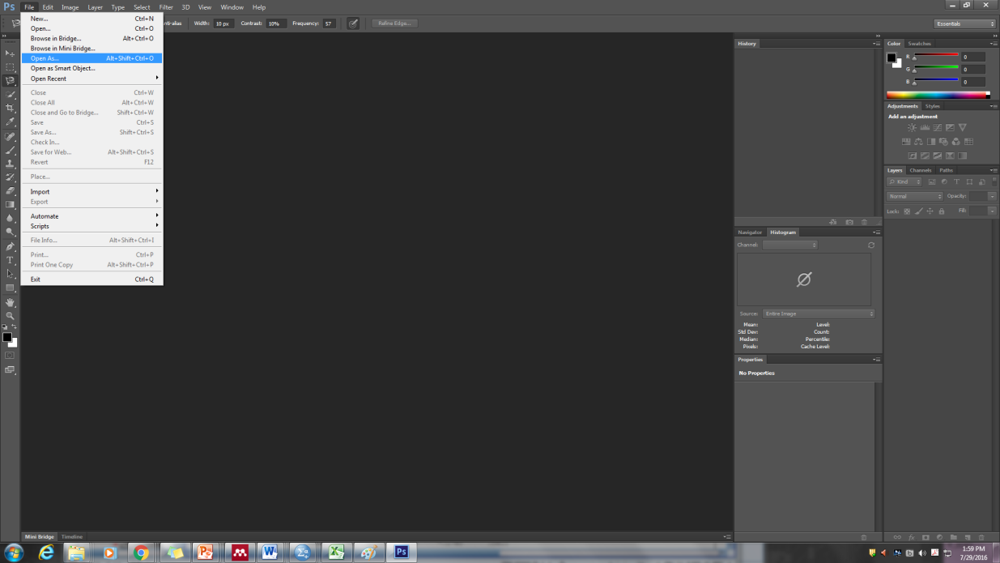

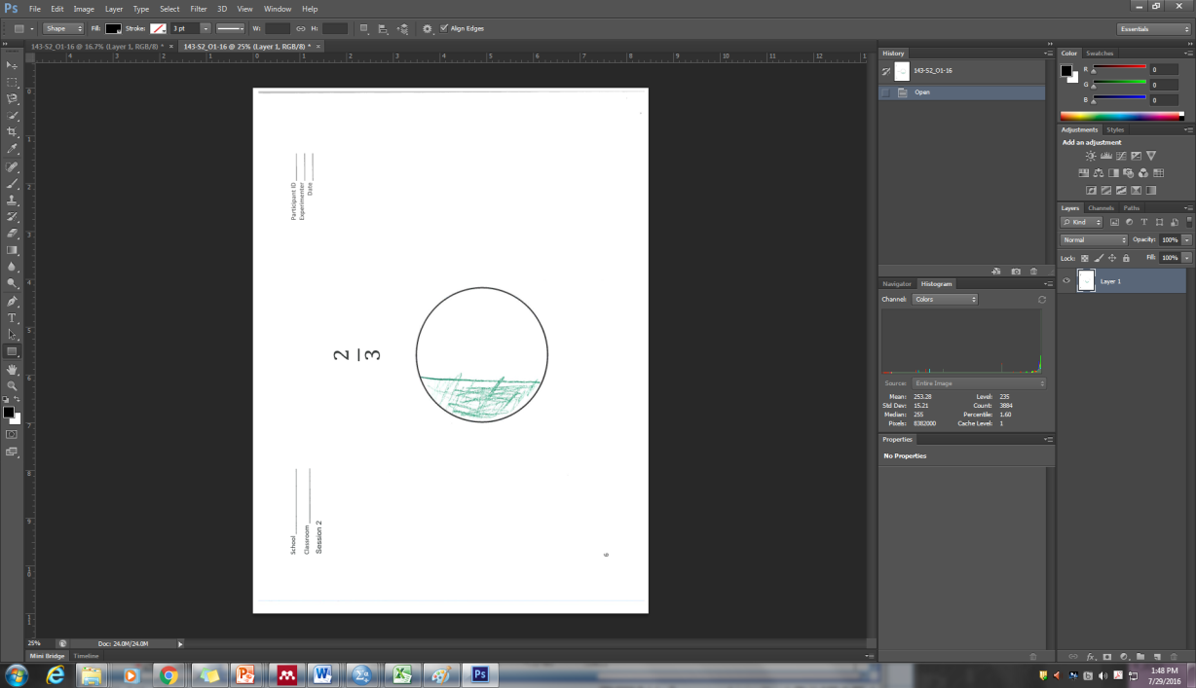

1. In order to count the pixels of the area, select the histogram window.
   1. Windows
   2. Histogram

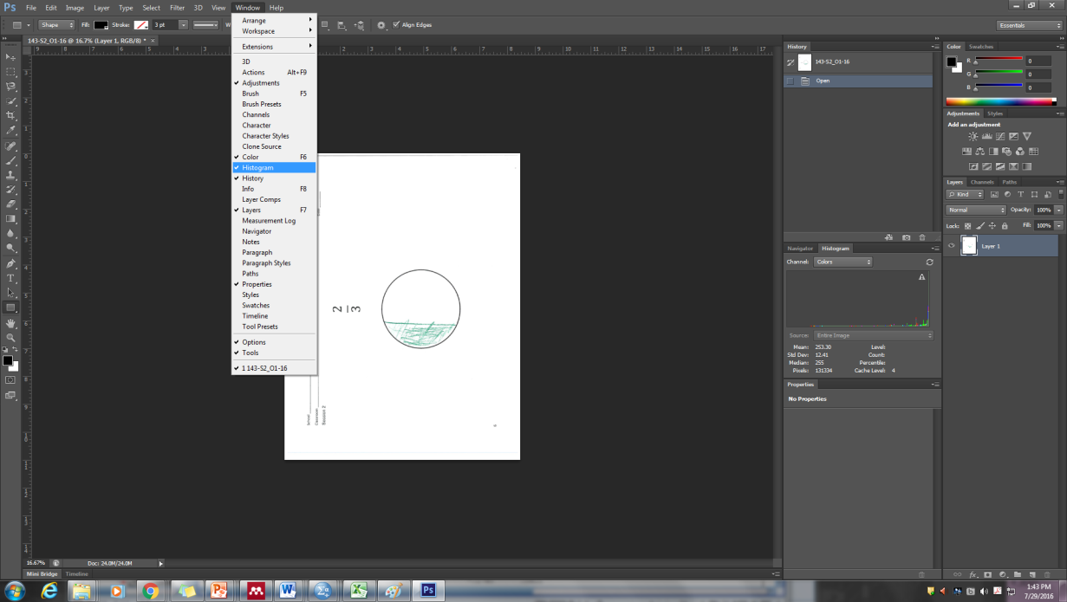

* 1. *Note:*Make sure that the triangle with the exclamation mark in the histogram box is gone before you start measuring the desired area. This triangle with the exclamation mark inside indicates caching pixels, and therefore, the total amount of pixels will not be calculated accurately when it is present. Simply click on the triangle to remove this function, so that it is no longer present, as shown in the image below.

1. Measuring the shaded area:
   1. Zoom in 100% by pressing *Ctrl* and + simultaneously.

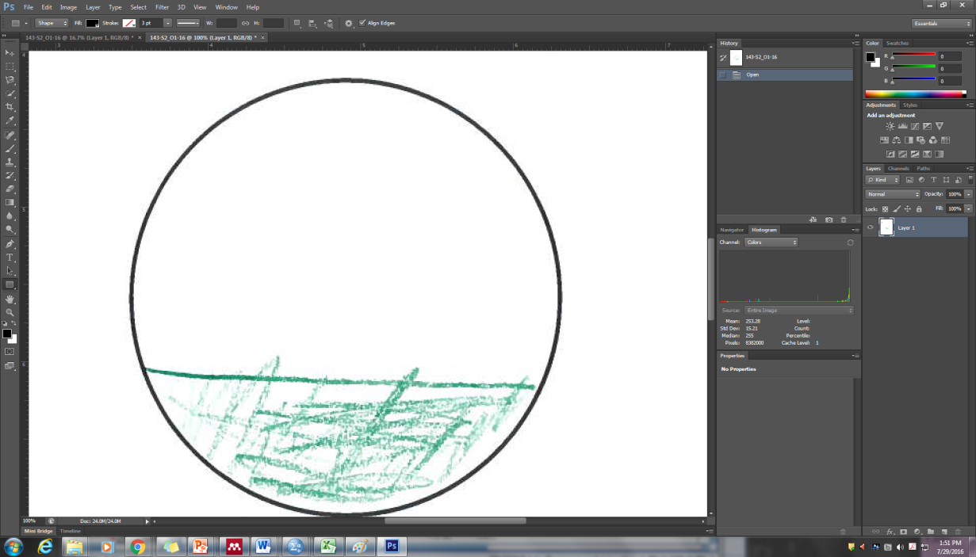

* 1. Select the magnetic lasso tool (left click on the third tool down the left hand bar, and select magnetic lasso).

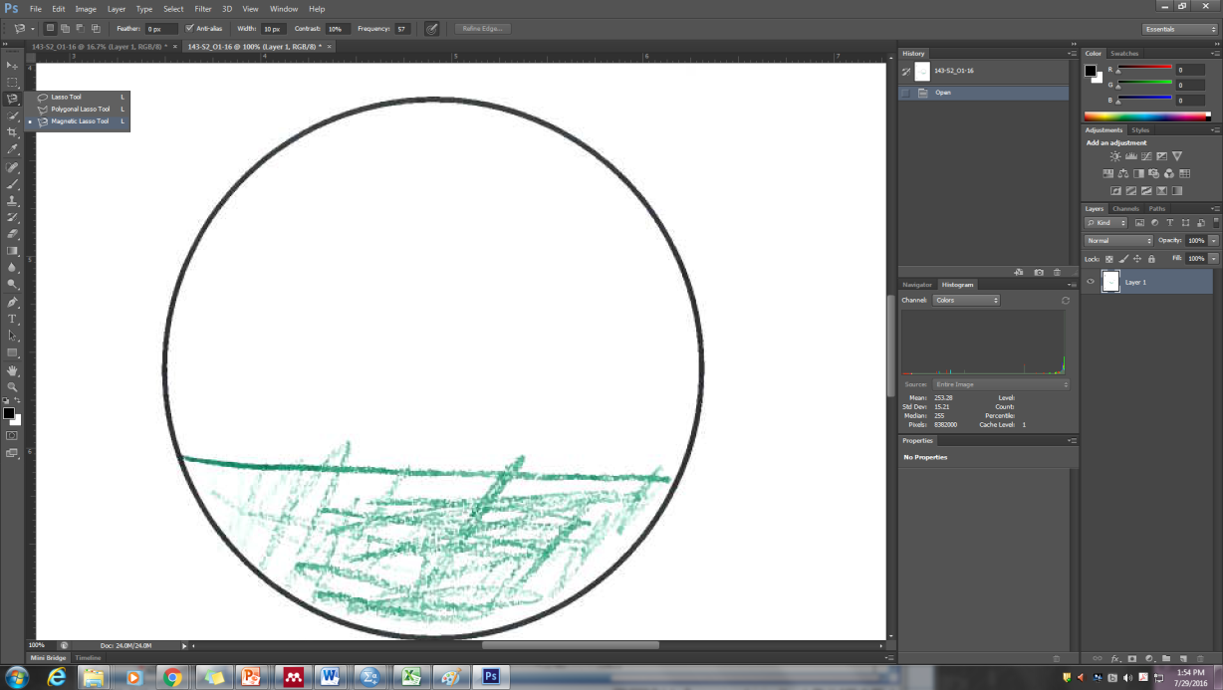

* 1. Click at any point on an inside edge of the shaded area and begin tracing along the area by simply moving your cursor around it. For odd edges, left click and then continue tracing. Each click will create a new point from which the trace will continue.
  2. Note: If you need to start this process over, simply hit the escape key and begin again.
  3. Once you’ve completed tracing the shaded area, and the beginning and end points of your trace meet, simply click your cursor at that point.
  4. Look at the pixels section of the histogram window and record the amount shown.

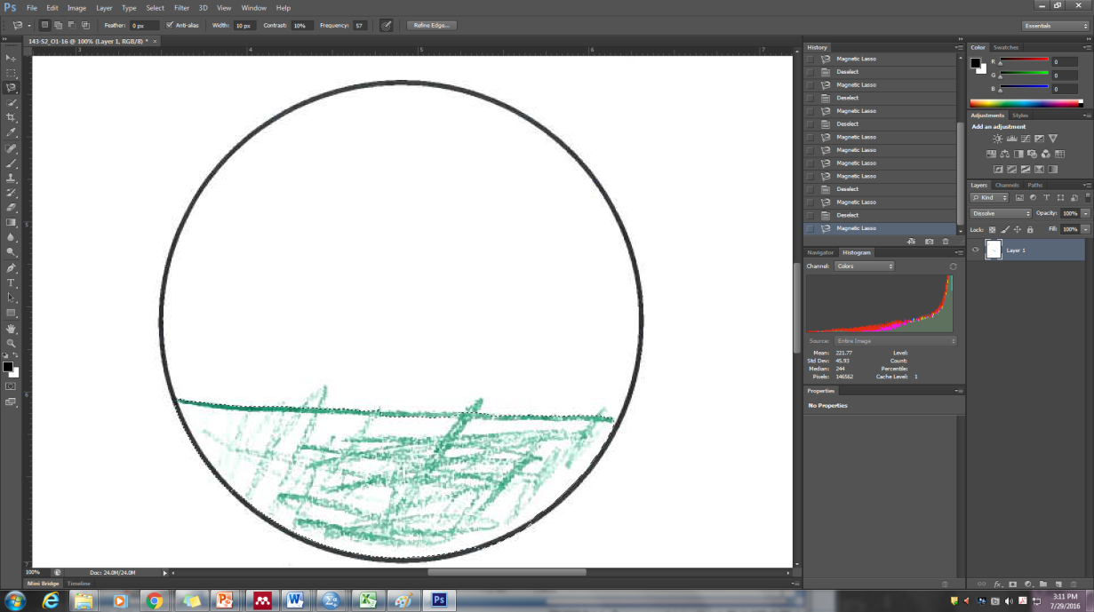

* 1. In order to calculate Percent Absolute Error (PAE), you will also need the total pixel count of the whole shape. In order to obtain this, follow the same procedure described here, but instead of merely tracing around the inside edge of the shaded area, trace around the inside edge of the entire shape. Use this total pixel count along with the shaded pixel count in calculation of PAE.